**BUDGET ANALYSIS AND REMINDER**

**PROJECT PLAN**

**Submitted By**

**Sandhya Sannapareddy 16181402**

**Haricharana Kanamarlapudi 16186977**

**Raghavendra Chirumamilla 16187866**

**Sampath Madineni 16185610**

**Introduction**: Budget Analysis and Reminder Android Application is useful for managing personal finance and helps in making a realistic assessment of your monthly or yearly expenses. This application helps to find the areas where you overspend the money and helps in controlling the unnecessary expenses.

**Project goal and objectives:**

* **Overall goal:** The main goal ofBudget Analysis and Reminder Application is to maintain the day to day budgets with ease without any manual calculations. It also set limit to the budget and give a reminder when the limit is exceeded.
* **Problem statement:** Managing your finances will involve lot of paper work, calculations. All financial information was either written down on paper and should be stored in files and any financial planning that took place was mostly in one’s head.

But to plan the monthly budgets using Budget Analysis and Reminder is easy and that can help not only in managing money but also in handling all aspects of personal finance.

* **Significance:**
* Application allows user to set limit to budget and gives alert when cross the budget limit
* Application will automatically give a warning when category wise budget limit exceed
* Application allows user to perform operations like add new expense, delete expense, update, add new category, delete category and view budget
* User can also add or remove family members and also helps to maintain their individual expenses
* Application allows to view category wise budget and also each family member budget info
* Application generates a statistically report of the yearly and monthly budget using bar graphs, line charts

**Proposed system:**

* **Requirement Specification:**
* **Functional Requirements:** Functional requirements capture the extended behavior of the system. This behavior may be expressed as services, tasks or functions that system is required to perform.

1. The Application initially requires user registration and provides the authentication by user id and password
2. The application have validation on login page and also in application where ever necessary
3. Application maintains the budget of user on daily, monthly or yearly basis and gives a reminder when budget limit exceed.
4. The user has the facility to categorize the expenses like House rent, grocery, electricity bill, mobile bill and so on.
5. The user can perform operations like add, update, delete, view expenses
6. Application helps to maintain the info about expenses of each family members.
7. Application allows to view monthly or yearly budget graphically using pie chart.

* **Nonfunctional Requirements**:

1. User friendly
2. Security
3. Maintainability
4. Performance
5. Scalability

* **Work flow Analysis:**

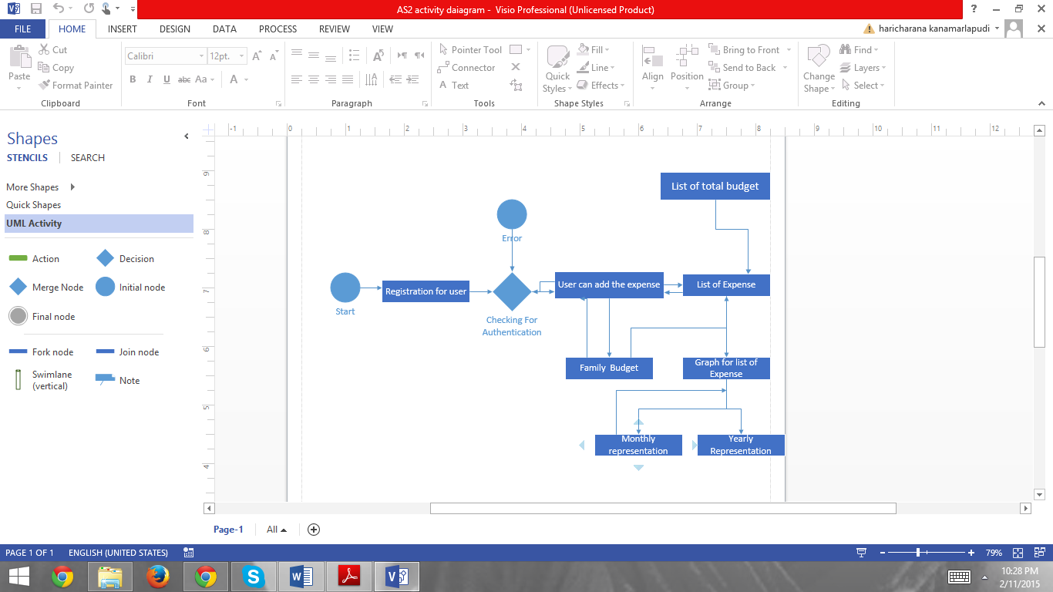

* **Technological and Architectural Requirements:**

Platform: Android OS

Tools: Visio

Eclipse IDE

SQLite

Constraints: Need internet connection for generating chart

* **Framework Specification:**
* **System Architecture:**

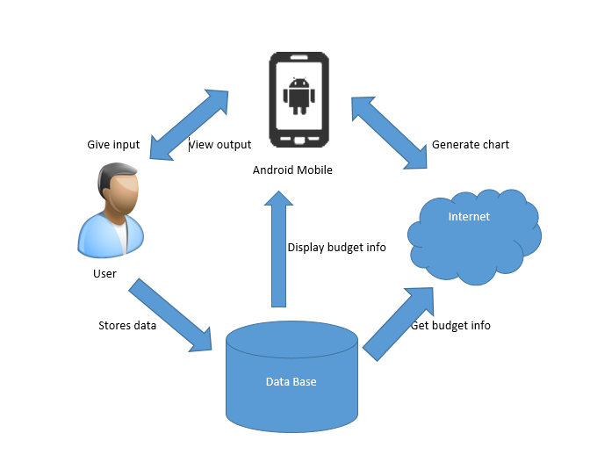

* **System Specification:**
* **Existing Service:**

1. **User Registration**: Initially the user should register and give all the required information and create an account.
2. **Login Service:** This service provide authentication to user by providing login id and password.

* **New Services:**
  1. **Register an Event:** In this service the user can add a new expense and also add description of the expense and categorize the expense. It also has facility to set limit to the budget.
  2. **List of Events:** Once the event is successfully registered it will be dispatched to the Event list in which the end user has the provision to edit, delete and view expense.
  3. **Family Budget:** This service is specific about family budget in which head of the family will manage the expenses of family members.
  4. **Reminder:** In this service the end user can set the reminder for each and every expense and notify the user when the budget limit exceeds.
  5. **Report:** This service will display the daily, monthly or yearly budget graphically using pie chart which is useful for self-assessment of monthly or yearly expenses.
* **Class Diagram:**

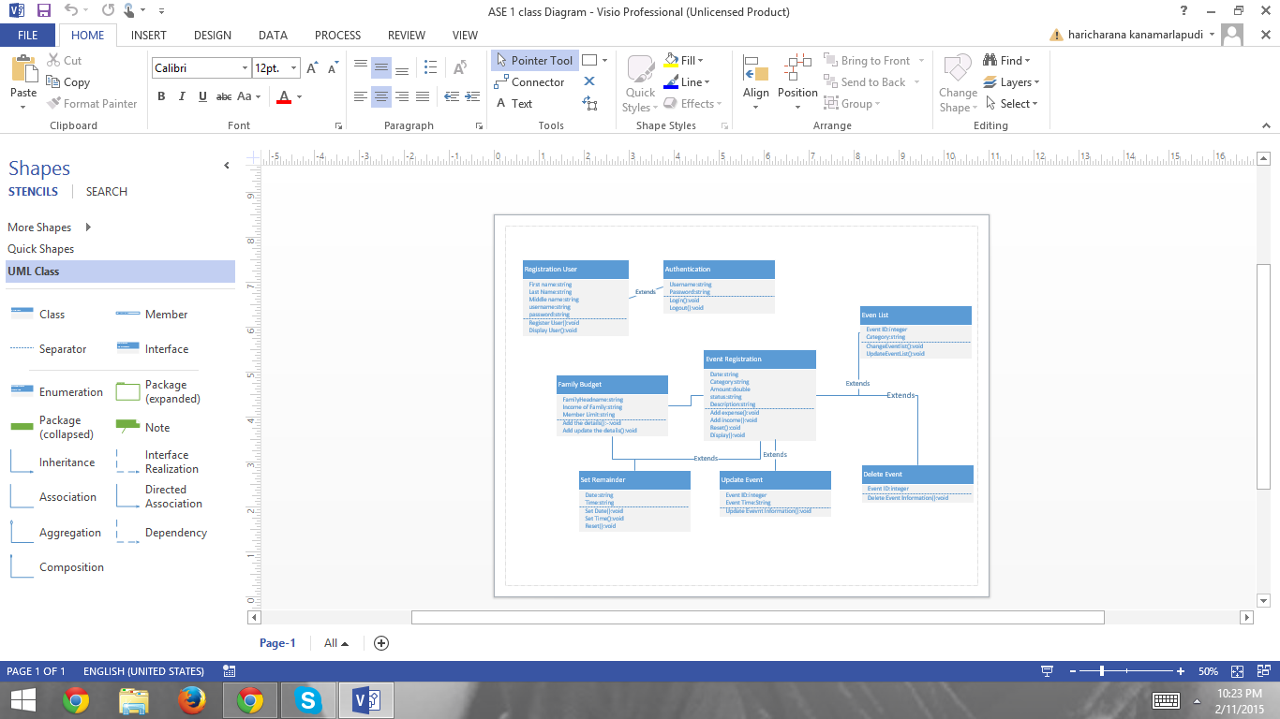

* **Sequence Diagram:**

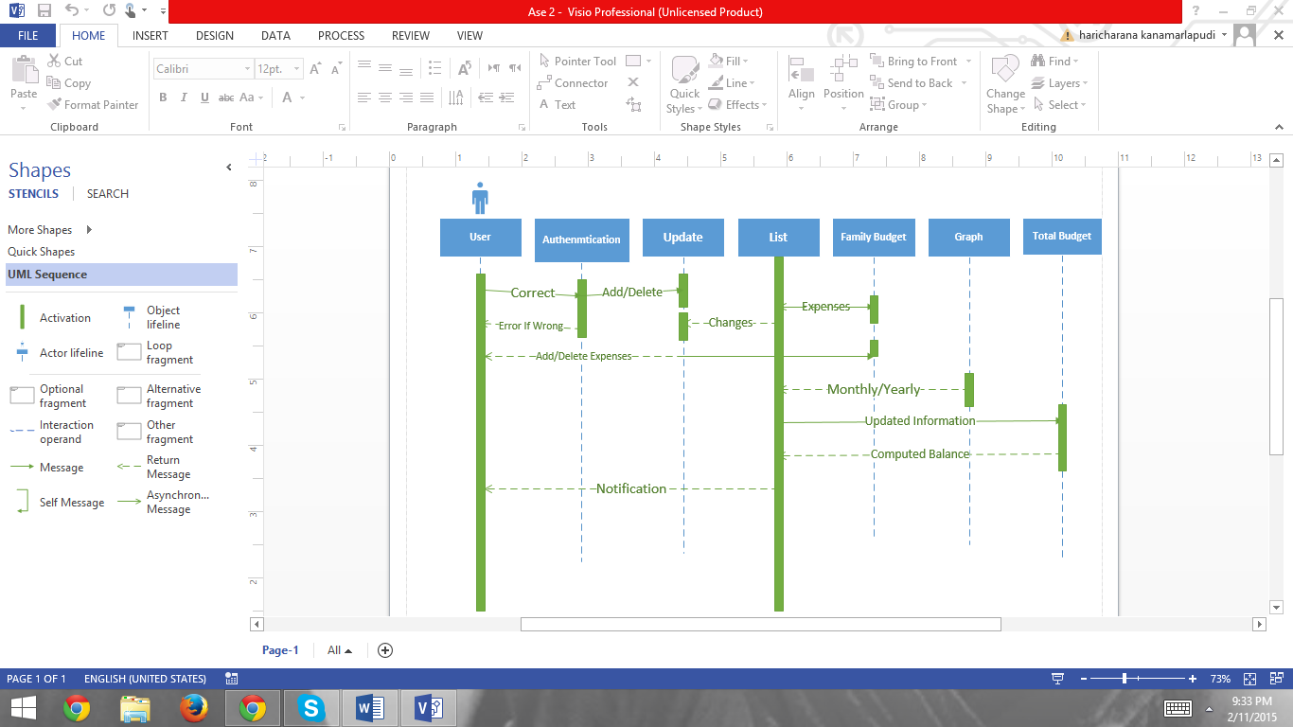

**Design of Mobile Client:**

* Hardware Requirements:

Dual core processor or 1GHz processor

RAM: 512 MB

SD Card: 50 MB

Device Type: Touch screen with LED screen

* Software Requirements:

Operating System: Android

Version: Gingerbread (2.3) or later

**Plan by Service (ScrumDo):**

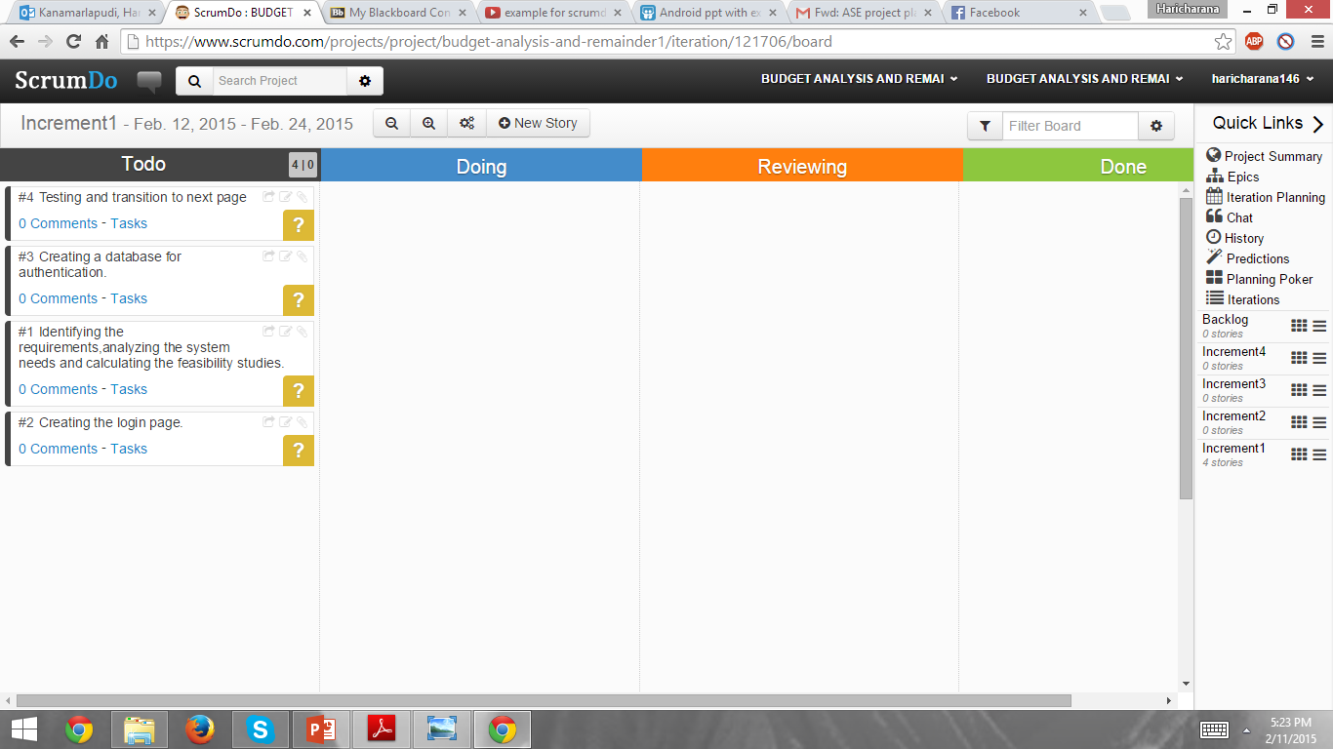

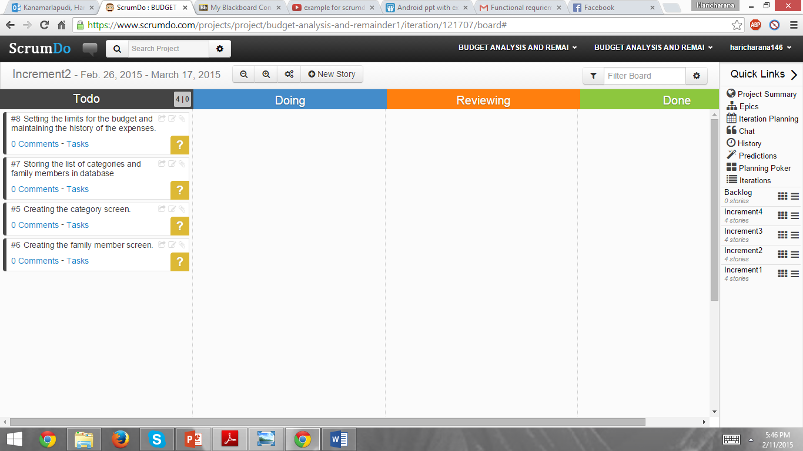

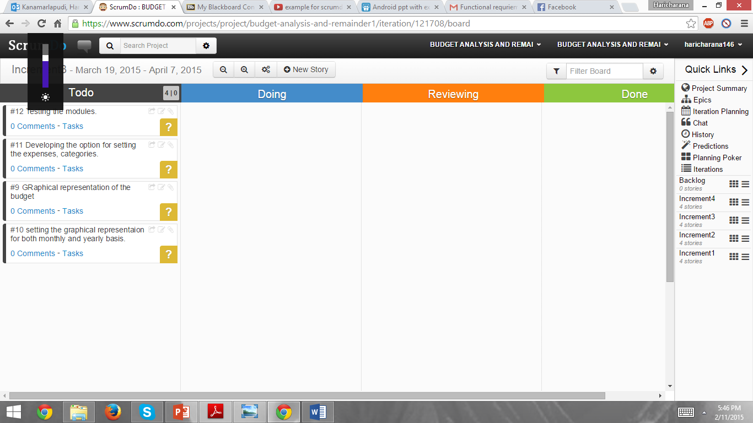

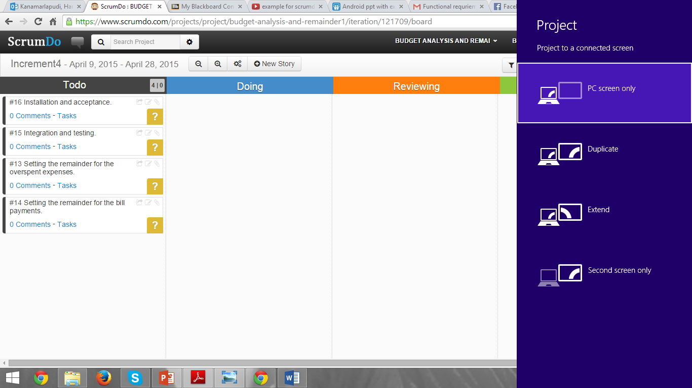

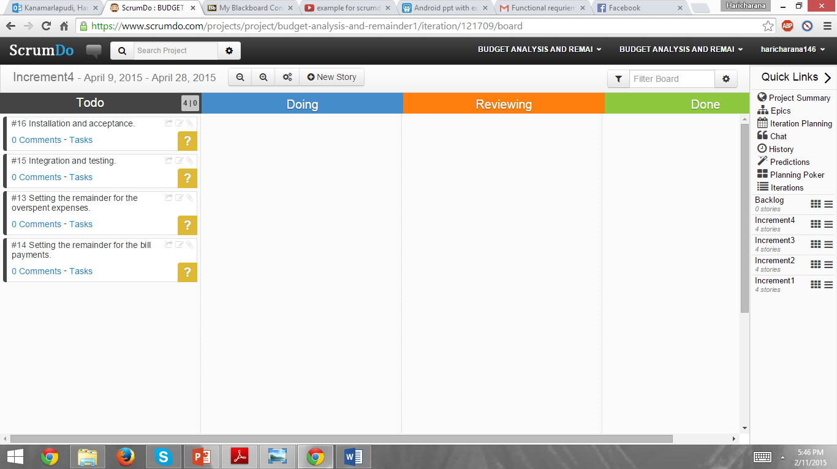

**Risk management:**

* Requirement Inflation
* Specification Breakdown
* Difficult project module integration

**Bibliography:**

[**http://www.viewandroid.com/2014/04/top-50-android-project-ideas.html**](http://www.viewandroid.com/2014/04/top-50-android-project-ideas.html)

[**https://www.elprocus.com/latest-list-of-android-projects-ideas-in-2014-and-their-applications/**](https://www.elprocus.com/latest-list-of-android-projects-ideas-in-2014-and-their-applications/)

[**http://www.electronicshub.org/android-projects-ideas/**](http://www.electronicshub.org/android-projects-ideas/)